**Daniel Tilley**

**C14337041**

**Operating Systems**

**Assignment**

**And Labs**

**DT - 228**

**Year 1**

**Computer Science**

**Table of Contents**

OPERATING SYSTEMS 1 LABS 3

Lab #1 4

Lab #2 5

Lab #3 9

Lab #4 13

OPERATING SYSTEMS 1 ASSIGNMENTS 14

Assignmment #1 15

# OPERATING SYSTEMS 1 LABS

## Lab #1

After analysing the problem myself and with two others (Mark and Baz), I came to the conclusion of how to rank my items. Although Mark, Baz and myself had similar views of what was and was not important, the way we rank our items was going to be different as we each have our own perspective for things. So how did I rank my list and why did I choose to order it as I have done?  
  
1) Two 110lb tanks of oxygen. Why? No brainer, you need it to live....  
2) Stellar map of the moons constellations. Why? Well you need to know where you are going before you start going anywhere, it’s not like you can ask someone for directions on the way.  
3) Solar powered FM Receiver/Transmitter. Why? To be able to make contact with the mother ship if anything goes wrong or if you get attacked by aliens or something like that....   
4) 5 gallons of water. Why? You sort of need water and all that walking would make me thirsty anyway.  
5) Life raft. Why? Although you have a spacesuit on and if you don't, well you would probably be long gone by this stage, but the sun’s rays are still pretty powerful and apparently they can do some serious damage or so I've been told and a life raft could be carried over your head to protect you from the sun and its rays. Alternatively you can use it as a bed.  
6) Parachute silk. Why? Same reason as the above one except it’s probably a bit easier to carry with just one person. As well you can use it as a duvet for your top of the range bed.  
7) Food Concentrate. Why? In case you get a bit peckish of course.  
8) First aid kit. Why? In case someone catches a disease up there, god knows what is going around on the moon..... Or if someone decides to pass out or something life threatening like that, it would be helpful to have.  
9) 50' of nylon rope. Why? You can use this for many things like tying your stuff together so it won't float away, Tying everyone together so they won't float away or even use it for entertainment if you get bored and pretend to be a cowboy.  
10) Box of matches. Why? Fire is always good but doesn't it need oxygen to burn and I've heard they haven't discovered that on the moon yet.....  
11) Portable heating unit. Why? In case you get cold, but then again if you are on the light side of the moon and the sun is shining down on you, would you really need it?  
12) Signal Flares. Why? You could shoot them up into the abyss but I don't think they would ever come back down..... I guess you could just shoot each other with them for fun.....  
13)  Magnetic compass. Why? I've heard that they don't work well on the moon, but I've never been so I don't know all too well to be honest.  
14) One case of dehydrated pet milk. Why? I enjoy me a god glass of milk but I suppose survival is just a wee bit more important.....  
15) Two .45 calibre pistols. Why? If worst comes to worst...... Its survival of the fittest unfortunately and I’ll make sure I'm carrying the guns.  
  
I think it’s safe to say that I'm doing the wrong course and should probably go and become an astronaut at this stage.

## Lab #2

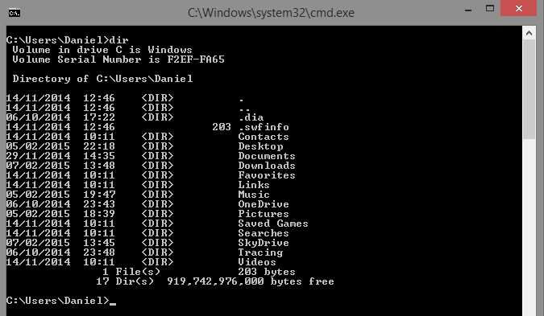

The dir command is used to show the different directories in whatever directory the user is in.

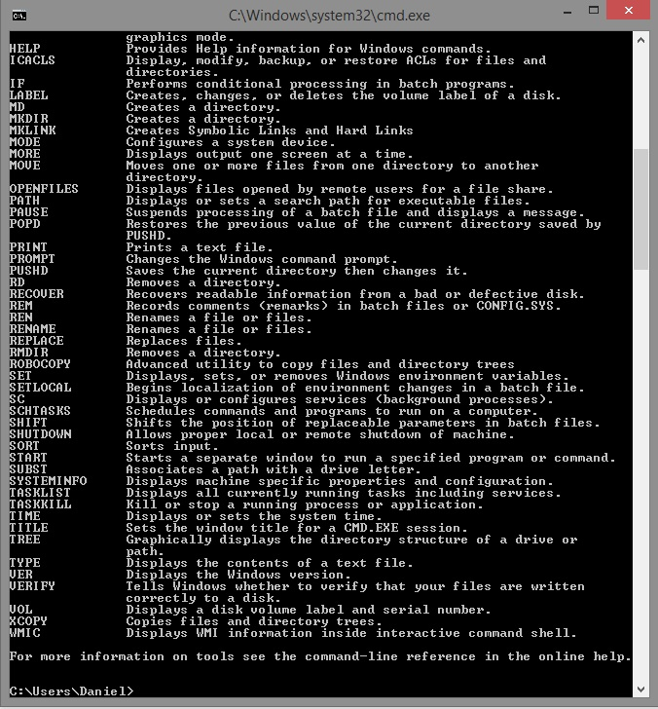

The help command is used to display a list of commands available to use in cmd.

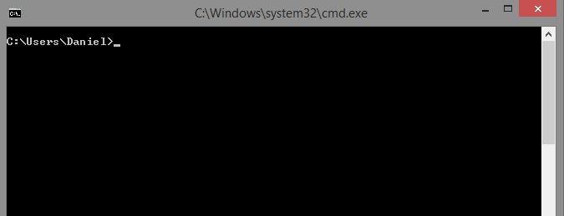

The cls command is used to clear the screen of previous commands the user has entered.

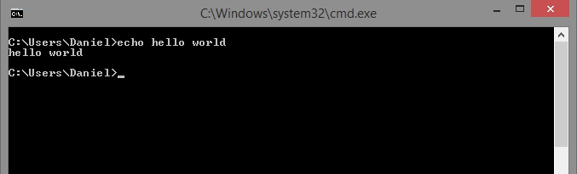

The echo command is used to repeat a message the user has entered.

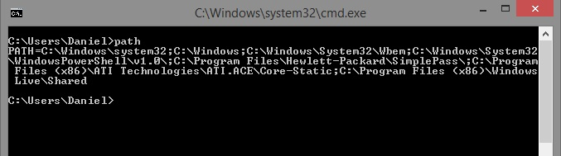

The path command displays or sets a search path for .exe files

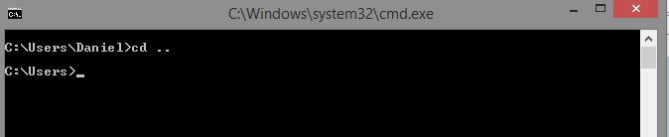

The cd .. command is used to move back up one directory

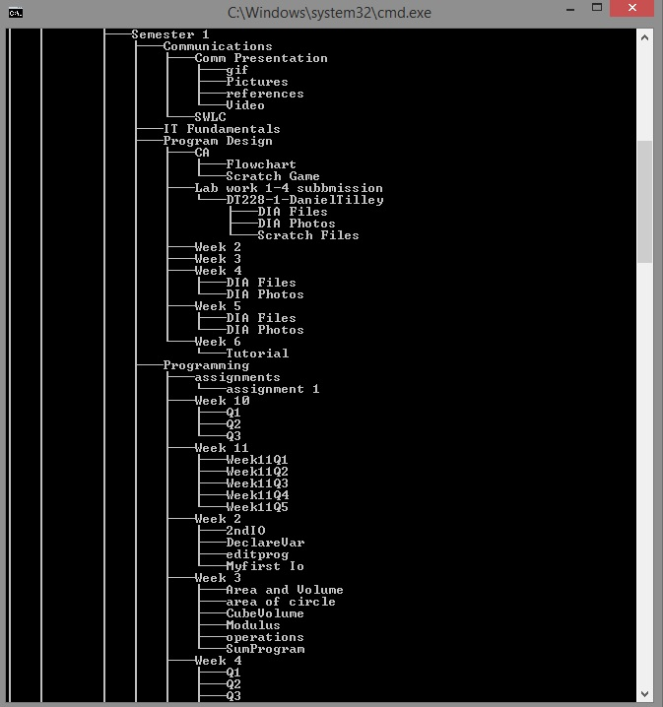

The tree command allows the user to a listing of files and folders in a "tree" format.

## Lab #3

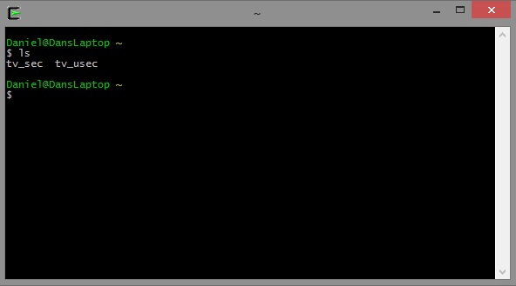

The "ls" command provides a tree like listing of a directory structure.

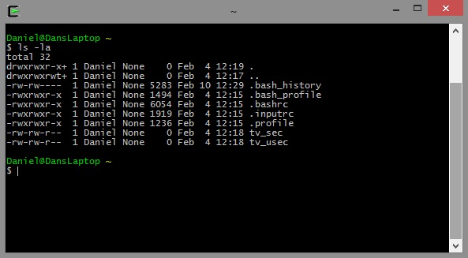

The "ls -la" command creates an alias that shows a long style listing of all files in the current directory.

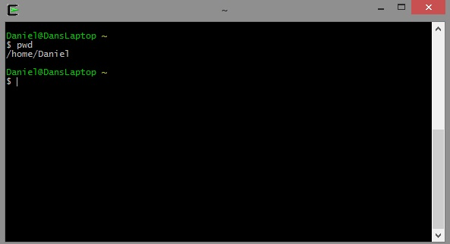

The "pwd" command allows you to know what directory you are in.

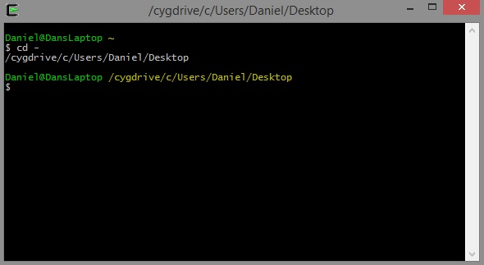

The "cd -" command allows you to navigate to the previous directory or to go back.

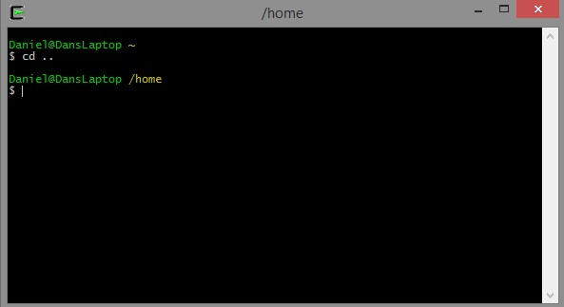

The "cd .." command allows you to navigate up one directory level.

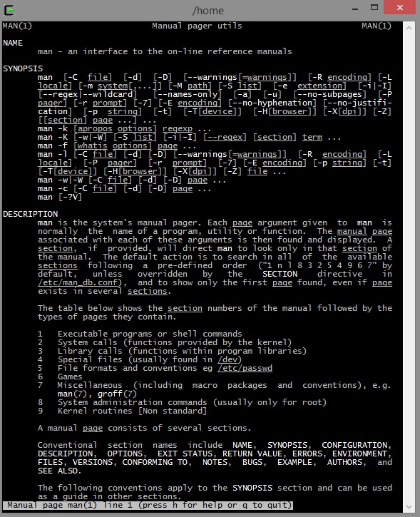

The "man man" command displays the on screen manual to the user.

## Lab #4

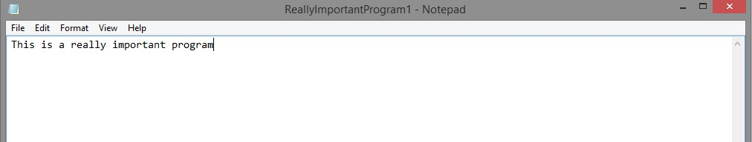

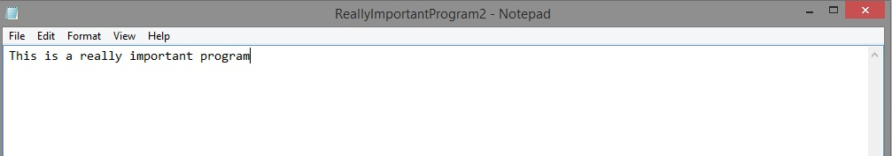

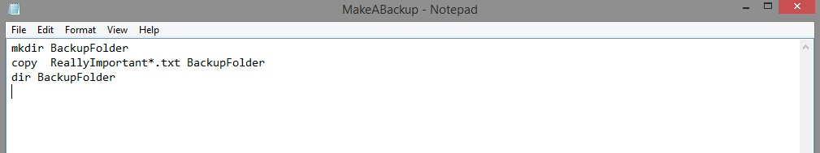

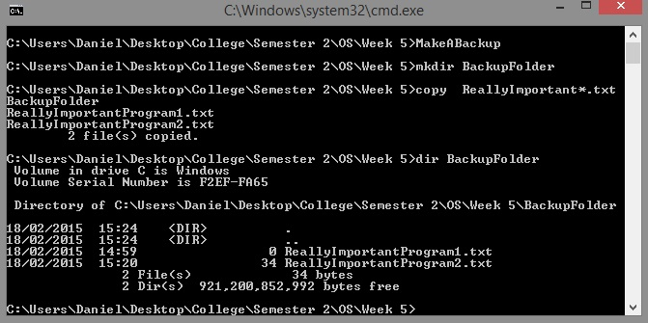

I created 2 ".txt" files which contained some text and also a ".bat" file which contained a list of commands that can be used in DOS. The batch file is a file that has a group of commands typed into it already and then once the batch file is executed, the commands within the batch file get executed. The commands within the batch file were ("mkdir") which created a new directory or folder for the two text files to be stored in called "BackupFolder", ("copy") which copied the two files "ReallyImportant*.txt" and ("dir") which stated the directory or folder that the two files had to be copied to called "BackupFolder".

# OPERATING SYSTEMS 1 ASSIGNMENTS

## Assignment #1

**Q1a**

For this question, I had to create a batch file which enabled the user to recursively backup directories and sub-directories and all files contained within them in Windows. For this task I found out that I had to use the “xcopy” command with the help of google. The “xcopy” command is a very powerful command that allows the user to do a lot of things with the help of switches. These switches can be used to indicate whether the user wants to do things such as copy an empty sub directory “/e”, only copy full directories, prompt the user to press a key before copying etc. The “xcopy” command itself allows all files and folders within a specified directory to be copied recursively to another specified folder. I also used several other commands such as the “dir” command which lists all files and folders within a certain directory, the “cd” command which allows the user to navigate through directories, the “mkdir” command which allows the user to create a new directory and the “@echo off” command to stop the command from appearing in the prompt when the batch file was run.

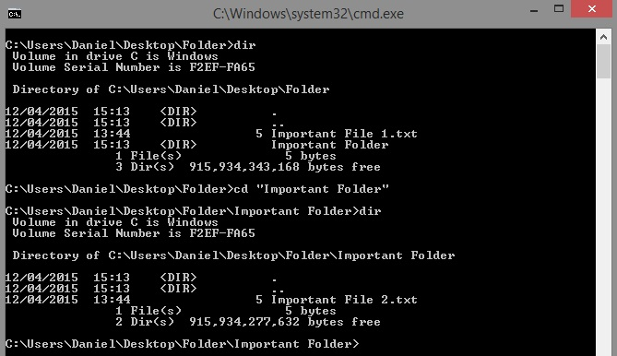

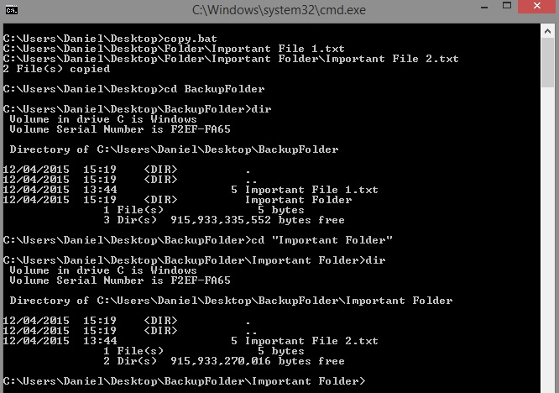

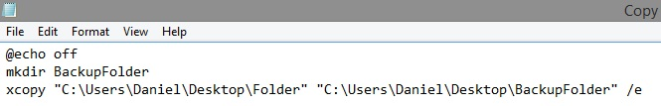

**Q1b**

For this question, I had to create a shell script which enabled the user to recursively backup directories and sub-directories and all files contained within them in Linux. I choose to do this on an Ubuntu distribution of Linux as I have it setup on a pc at home. This question was a bit trickier for me as I am relatively new to the Linux world; however, google was there to help when things got a bit tricky. As well as this, I played around with different things and figured out to make things work. I used a number of different commands for this script such as the “cp” command which was the main command used in the script. It allowed the user to recursively backup files and directories by using the “cp –R” option. The “echo” command allowed me to create new text files within a new directory that I have created using the “mkdir” command. The “cd” command was used to navigate to different directories and the “ls” command was used to list the contents of these directories. With regards to the shell itself, the “vi” editor was used to create the shell, the “chmod” command was used to give execution access to the script and the “cat” command was used to show the contents of the script.

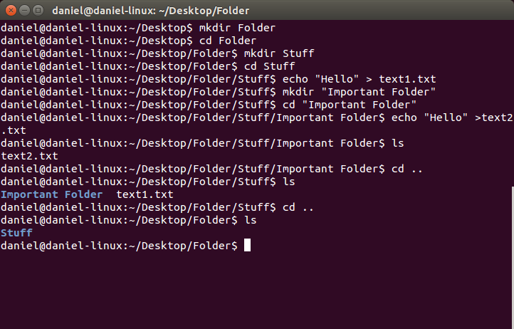

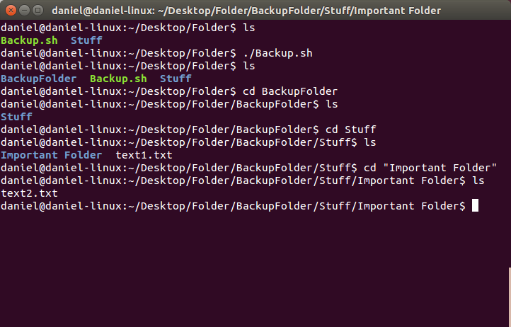

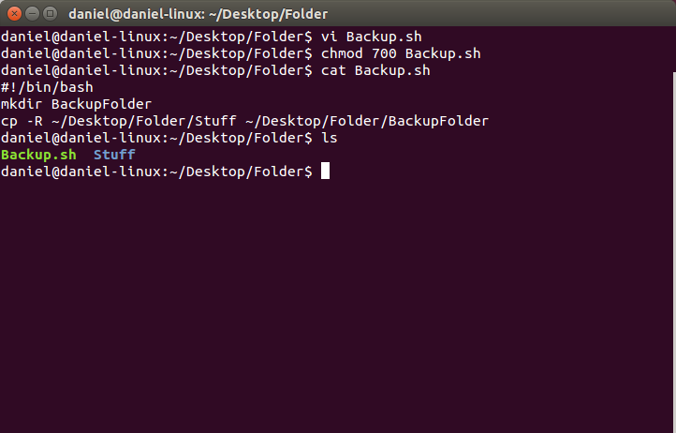

**Q1c**

Write a program using the Little Man Computer codes to take two numbers which are contained in the IN-TRAY and display the sum (+) of those numbers in the OUT-TRAY. Comment every instruction

1. 901 (Input first number from IN-TRAY and enter into calculator)
2. 308 (Store the value in the calculator into memory)
3. 901 (Input second number and enter into calculator)
4. 309 (Store the value in the calculator into memory)
5. 508 (Load the first value back into the calculator)
6. 109 (Add the second number to the first value)
7. 902 (Output the result to the OUT-TRAY)
8. 000 (Take a break)

### Group Reflections

Upon first hearing we had an assignment to do, we began to guess what the assignment would be and how we would have to complete it (i.e. in groups or an individual assignment). Much to our surprise we were given both of these options. At first I was a bit sceptical about working with other people I hadn’t worked with previously or even talked to that much, however, as things got going and we got to know each other a little better, I wondered why I had even started worrying in the first place.

In my eyes, I’m the type of person who likes to get stuff done and not mess around when it comes to doing things and luckily I was grouped with four other class mates who shared the same work ethic as me. Our group consisted of Andrew Leech, Cein O’Rourke, Éanna Brennan, Jordan Forde and I. Our assigned operating system was “Visi-On” and we had absolutely no idea what it was or anything about it or its creators.

Our first meeting was held just after the OS class on March 4th which was the day the assignment was handed out. Our first order of business was establishing a Facebook group chat or page so we could discuss ideas and share work we had done online with one and other. The group page was setup by Éanna who had the first important task of adding us all on Facebook and sorting the group out. Once the Facebook group had been created, it was a lot easier to discuss ideas with one another and layout the tasks that we all had to complete. We decided as a group to leave the work to one side for a week so that we could all focus on getting assignments that were due that week finished and out of the way.

The real work began on the 12th of March after we had finished all of our other urgent assignments. We decided to divide up tasks and assign everyone with roles. I was appointed as the leader and would assign my group with an even amount of work so that no one was doing all the work or none at all, including me. Andrew was given the task of designing the PowerPoint and merging all the slides together, Éanna had already created the group so that left Cein and Jordan as the two main researchers for the group. They would find websites that would come in handy for creating our own individual slides. During this meeting we also decided to change the operating system to something that that was a lot more interesting. In the end we decided on J.A.R.V.I.S. We also came up with our own brief notes on what pieces of information we should use in the slides so that it would make things a whole lot easier when we were researching information for our slides.

Another meeting was held the following week on the 19th of March so we could all check up on each other and so that we could finalise everything before we began our research. The week in between gave everyone the chance to come up with ideas of what they could add to the presentation to make it more interesting and entertaining. We also decided to hold the meeting earlier in the day at 11 am as many of us had a five hour break in-between the previous class and the OS lab. It gave us a chance to meet up with before someone disappeared home early and left the group a man short. During this meeting we decided that we should begin our research week and get it out of the way as to maximise the amount of time we had to do our slides.

After our extremely productive research week we met up again on the 26th of March before breaking up for the Easter break. We brought forward all our ideas and discussed them with the group and everyone gave feedback on one another’s ideas. This was a really good way to get an idea of what everyone thought of one another’s work and what the PowerPoint was going to look like overall. Andrew had already laid out the template so all we had to do as a group was fill in the blanks and create a fantastic presentation. We gave ourselves until the 9th of April to finish the PowerPoint presentation off so we would have it good and ready for when we got back. I also made sure that we had plenty of time to do the presentation (two weeks) so as that there were no excuses about not having it done on time.

After an enjoyable two weeks off, we got back to work. Our final meeting was held on the 14th April so that we could wrap this whole thing up, put it all together and have a trial run at presenting. We met up in the snackery at 10 am, gave all the work we had done to Andrew, put it all into one file and then practised speaking in front of one another. Some people were a bit nervous about presenting, however once they got started, they quickly overcame their nerves. All in all the meeting ran like clockwork and everyone did their fair share of work which in my opinion is a job well done.

With regards to the slides themselves and what amount of work everyone put in, it was an all-round team effort with everyone contributing, their 20%. Everyone documented their own experience as to give the essays a more personal edge to them. As well as this, everyone did their own research for their slides sing links that Jordan and Cein found for us (listed below) and obviously the movies themselves. In the end, we all managed to create four slides each with dealt with things such as biographies, users, architecture, comparison to other OS, pros and cons and a very simple yet effective conclusion.

A total of 6 meeting were held and took place on a weekly basis and they turned out to not only be very helpful with the assignment, but also to let us get to know one another a bit better. In the end we chose a very appropriate team name. The “D.I.T Avengers” seemed fairly fitting with regards to the OS we were doing.

In conclusion, I found this assignment to be very interesting and enjoyable. I got to work with four hard working and charming lads who pulled their weight with regards to work and had no problems at all. The group worked extremely well together and was able to come to an agreement with everything relatively easy. The teamwork aspect was a great experience and gave me a good idea of what is to come in later life, as well as helping me to improve some of my key skills with regards to the working world.

**Resources Used For PowerPoint**

1. ‘J.A.R.V.I.S’ (no date). Available at: http://marvel-movies.wikia.com/wiki/J.A.R.V.I.S. (Accessed: 21 March 2015).
2. ‘J.A.R.V.I.S.’ (no date). Iron Man Wiki. Available at: http://ironman.wikia.com/wiki/J.A.R.V.I.S. (Accessed: 20 March 2015)
3. Favreau, J. (2008) *Iron Man*, *IMDb*. IMDb. Available at: http://www.imdb.com/title/tt0371746/ (Accessed: 20 March 2015).
4. Favreau, J. (2010) *Iron Man 2*, *IMDb*. IMDb. Available at: http://www.imdb.com/title/tt1228705/?ref_=nv_sr_2 (Accessed: 20 March 2015)
5. Black, S. (2013) *Iron Man 3*, *IMDb*. IMDb. Available at: http://www.imdb.com/title/tt1300854/?ref_=nv_sr_1 (Accessed: 20 March 2015).
6. Whedon, J. (2012) *The Avengers*, *IMDb*. IMDb. Available at: http://www.imdb.com/title/tt0848228/?ref_=nv_sr_1 (Accessed: 20 March 2015).
7. *Google Images* (no date). Available at: https://images.google.com/ (Accessed: 20 March 2015)

### PowerPoint Presentation

